Gathering Personal Information Using Online Sources:

# Name: Rafay Baloch

## Profession: White-Hat Hacker

# Further Information:

Name: RAFAY BALOCH

Caste: Baloch

Religion: Islam

Nationality: Pakistan

Born: Pakistan

DOB: 3 February 1993.

Net Worth in 2021: $1 Million - $5 Million

Initial Studies: Pakistan

Currently located: London.

# Social sites:

## Facebook.com:

### Facebook Page:

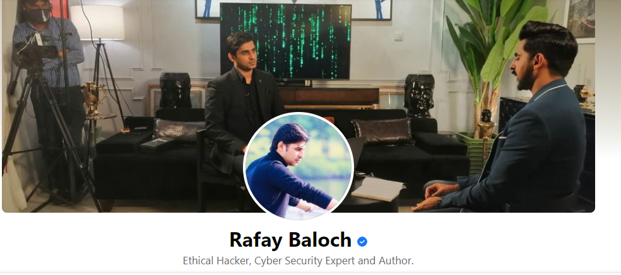

**Contact Info:**

rafaybaloch@gmail.com

**Websites and Social Links:**

https://www.rafaybaloch.com/

**Current city:**

London, United Kingdom

**Page Creation Date:**

November 29, 2010

**Page Admin Info**:

This Page can have multiple admins. They may have permission to post content, comment or send messages as the Page.

### Facebook ID: https://www.facebook.com/rafaybalochofficialpage

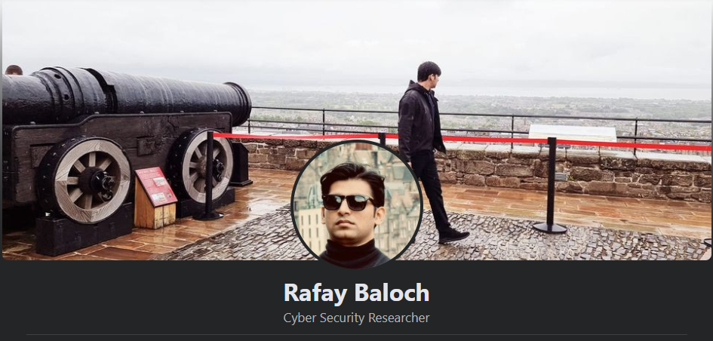

**Working**:

Former Former Advisor Cyber Security at Pakistan Telecommunication Authority

August 8, 2018 to August 8, 2020

**Education**:

No schools to show

**Living**:

From Islamabad, Pakistan

Islamabad, Pakistan Hometown

**Relationship**:

It's complicated

**BOD:**

5 February 1993

**Languages**:

Urdu, English language, Balochi language, Sindhi language and Pashto

**Recent places he’s been to:**

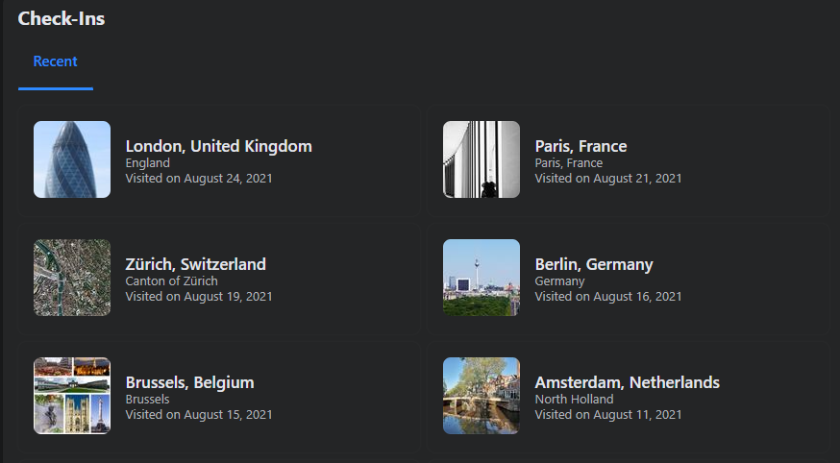

**Facebook ID was created in:** January 2009.

## Instagram Account: https://www.instagram.com/rafaybalochofficial/?hl=en

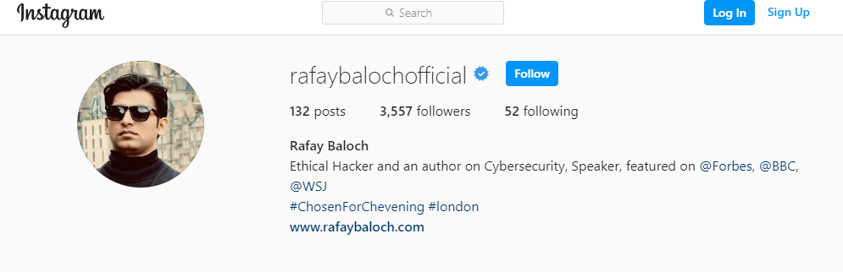

## Twitter account: https://twitter.com/rafaybaloch

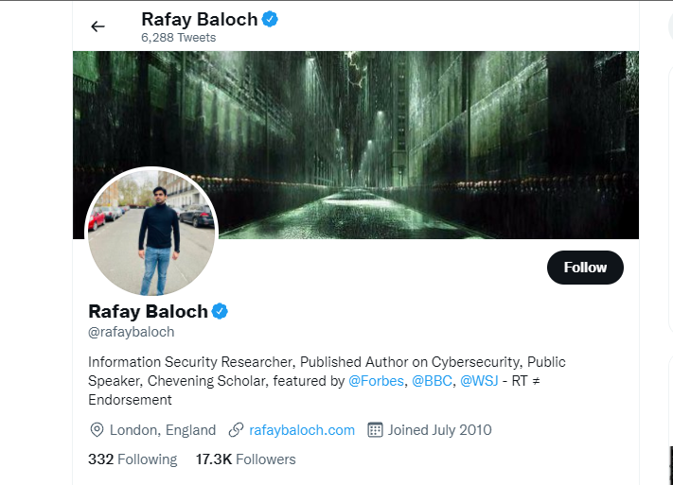

## Linkedin Account: https://linkedin.com/in/rafaybaloch

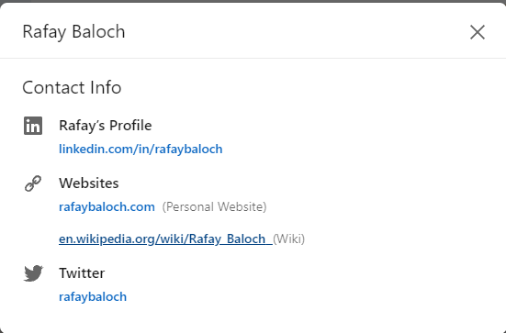

**Location by linkedin.com:**

United Kingdom (UK)

**Education**:

Bachelors in Computer Science from Bahria University Islamabad.

Masters in Information Technology from Riphah International University.

# Wikipedia:

Rafay Baloch (Urdu: رافع بلوچ‎‎, born 5 February 1993) is a Pakistani ethical hacker and security researcher known for his discovery of vulnerabilities on the Android operating system. He has been featured and known by both national and international media and publications [1][2] like Forbes,[3] BBC,[4] The Wall Street Journal,[5] and The Express Tribune.[1] He has been listed among the "Top 5 Ethical Hackers of 2014" by CheckMarx.[1][6] Subsequently he was listed as one of "The 15 Most Successful Ethical Hackers WorldWide"[7] and among "Top 25 Threat Seekers" [8] by SCmagazine. Baloch has also been added in TechJuice 25 under 25 list for the year 2016 and got 13th rank in the list of high achievers.[9] Reflectiz, a cyber security company, released the list of "Top-21 Cybersecurity Experts You Must Follow on Twitter in 2021" recognizing Rafay Baloch as the top influencer.

# Personal website:

https://www.rafaybaloch.com/

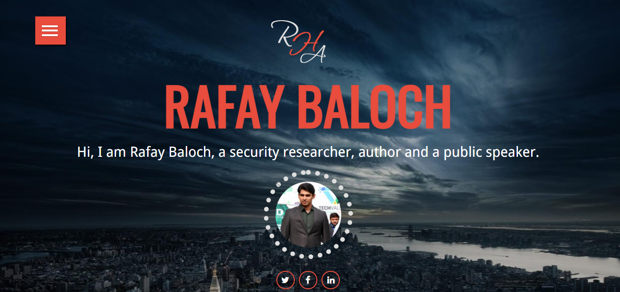

# Others Websites:

Overview of Rafay Baloch’s life.

<https://medium.com/hash-intelligence/rafay-baloch-30e76ad7622e>

Book written by Rafay Baloch on ethical hacking.

<https://books.google.com.pk/books/about/Ethical_Hacking_and_Penetration_Testing.html?id=tGoLBAAAQBAJ&printsec=frontcover&source=kp_read_button&hl=en&redir_esc=y#v=onepage&q&f=false>

